TASK ACCOMPLISHED IN ORGANIZATION

4.1 Development of Radiation Dataset
So, the first phase of the project went into building a more structured radiation dataset, to help with visualization plus analysis stuff. Basically, we took the radiation readings along with GPS coordinates and environmental parameters, also the timestamps, then put it all into a standardized layout. After that, the dataset got published on Kaggle, so people could use it for research, testing, and later model development. In practice, this dataset became the base layer for producing radiation heatmaps and for checking whether the visualization algorithms were working or not.
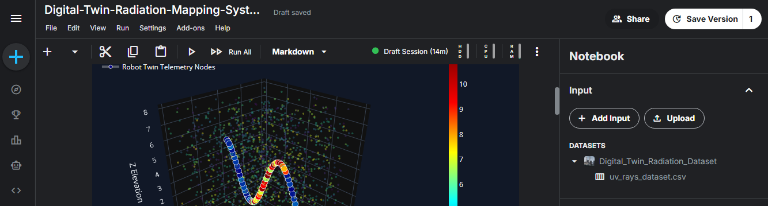
Figure 1: Kaggle Dataset (Dataset page or CSV preview)

4.2 Development of 2D Radiation Heatmap
So, a two dimensional (2D) radiation heatmap was developed, basically to show how the radiation intensity ends up distributed over different geographical places. The whole system used radiation readings that came from a Gamma Spectrometer, and then matched those measurements with GPS positions in real time from the GlobalSat BU-353N GPS Receiver. Each single radiation value was then placed onto the geographical point it belonged to, so that the radiation levels across the observed region could be visualized accurately, or at least in a way that looks consistent and clear.
The generated heatmap basically showed radiation intensity with a color gradient, where the lower radiation levels were shown in cooler colors, like blue green. While the higher radiation levels showed up in warmer colors, such as yellow, orange, and red. In general this kind of picture made it a bit easier to spot the radiation hotspots and also look at how radiation changes around the surveyed area, in a spatial way, over distance.
To improve the analysis, we also included a few additional factors like the radiation count rate, the peak channel, GPS coordinates, a timestamp, plus temperature and humidity. These inputs were mapped together so they sort of gave a more holistic snapshot of the environmental state next to the radiation readings. In the end, this helped the visualization feel more accurate and reliable, rather than just relying on radiation alone.
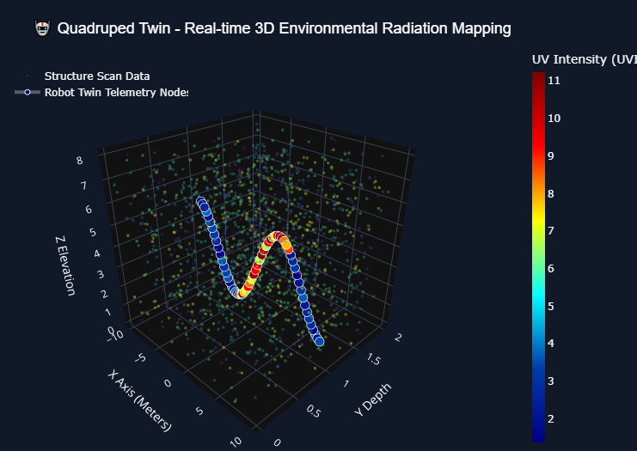
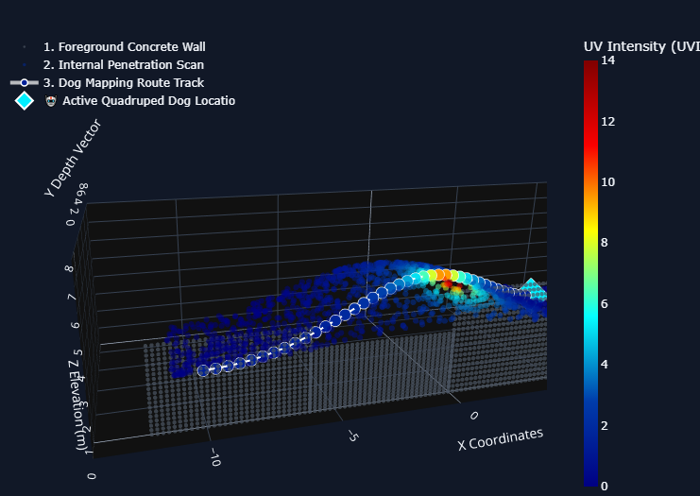
Figure 2: Static 2D Radiation Heatmap Output Generation with Dataset
4.3 GPS Integration with Raspberry Pi-5
Getting RADMAP to work well, honestly it needed pretty exact geographic positioning to map the radiation readings right. So, the GlobalSat “BU-353N” USB GPS Receiver was connected into the Raspberry Pi-5 so it could grab live location data straight from the GPS satellites. The GPS unit then talks to the Raspberry Pi over the USB link and it keeps sending NMEA, (National Marine Electronics Association) sentences that carry the key navigation details, all the time.
We put together a Python based data acquisition module, kind of to pull out and later sort GPS details like latitude, longitude, altitude, UTC time, speed, satellite condition, and how accurate the position is. At the same time, beside the GPS telemetry, we also grabbed environment numbers such as temperature and humidity using the DHT22 sensor and then synced all of that with the location data. It means during radiation monitoring, we could collect the geographical info and the weather-is context together, more or less in parallel.
The collected GPS coordinates were pretty much tied to the radiation counts that came in from the Gamma Spectrometer, so each time we measured radiation it also got mapped to the exact location. In a sense, that synced dataset, became the foundation for making the interactive 2D radiation heatmaps and later it also turned into the input for a 3D Digital Twin visualization system.
Special focus was placed on real-time communication, and on keeping the data in lockstep so that the time delay between the sensor readings and the GPS updates stayed as low as possible. Python based serial communication tools were used to keep watching the incoming GPS stream, then to parse the NMEA messages, and finally to save the processed results into organized data structures for more digging, analysis and visualization. Overall, the combined setup delivered a trustworthy telemetry framework, one that can help future mobile radiation monitoring efforts and even support autonomous navigation style applications.
The successful integration of GPS tech has, like, really boosted the RADMAP system’s overall ability. It allows for real time geospatial radiation mapping, better environmental record keeping, plus smooth synchronization with the backend visualization platform. In practice it means the platform can track locations more precisely; capture data as it happens and then line up those updates with the visualization side, without the usual delay or awkward gaps.
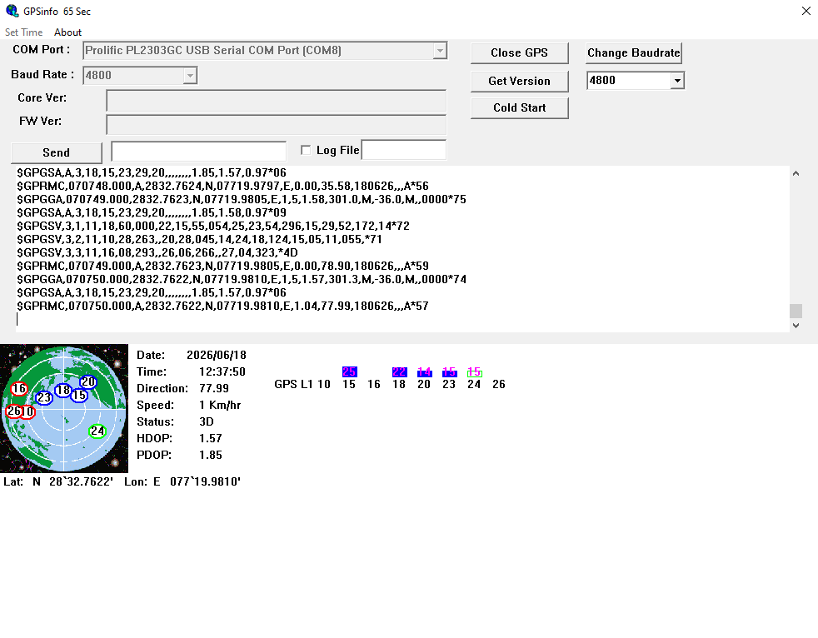
Figure 3: Live GPS Data Terminal Output

4.4 Gamma Spectrometer Integration and Radiation Validation
A critical component in the RADMAP setup is the CNSPEC Multi-Channel Analyser, basically a Gamma Spectrometer, and it was put in place so it could do real time gamma detection along with spectral analysis. This Gamma Spectrometer is used to measure energy and also the intensity of gamma radiation that comes from radioactive materials, in a way that makes it possible to get a solid identification and a more exact, quantitative analysis of the radiation level.
While doing the internship, the spectrometer got configured and sort of interfaced with the Raspberry Pi based backend, for on-going acquisition of radiation measurements. The detector itself was validated in practice with certified radioactive calibration sources, including Cobalt-60 (Co-60) and Cesium-137 (Cs-137) . These sources were picked due to their pretty clear gamma energy peaks, and that made them good for calibration tasks, and also for performance checking.
From the radiation measurements that were collected, a few Python visualization modules were crafted to show radiation count rates, peak channels, intensity graphs, and assorted statistical indicators. After that, the processed measurements were also synchronized with GPS coordinates, so location aware radiation maps could be generated, and in a way they became more meaningful for real world referencing.
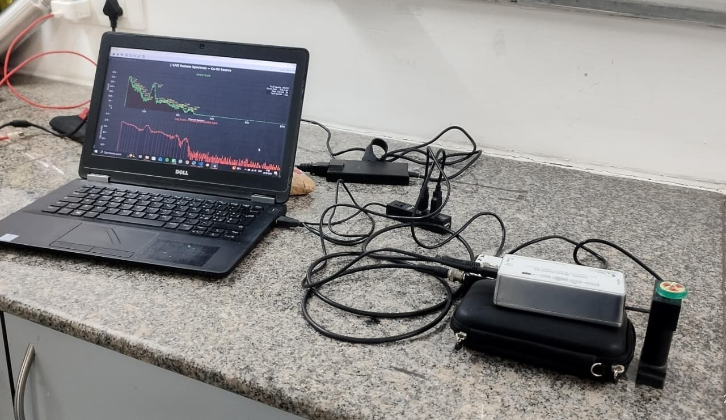
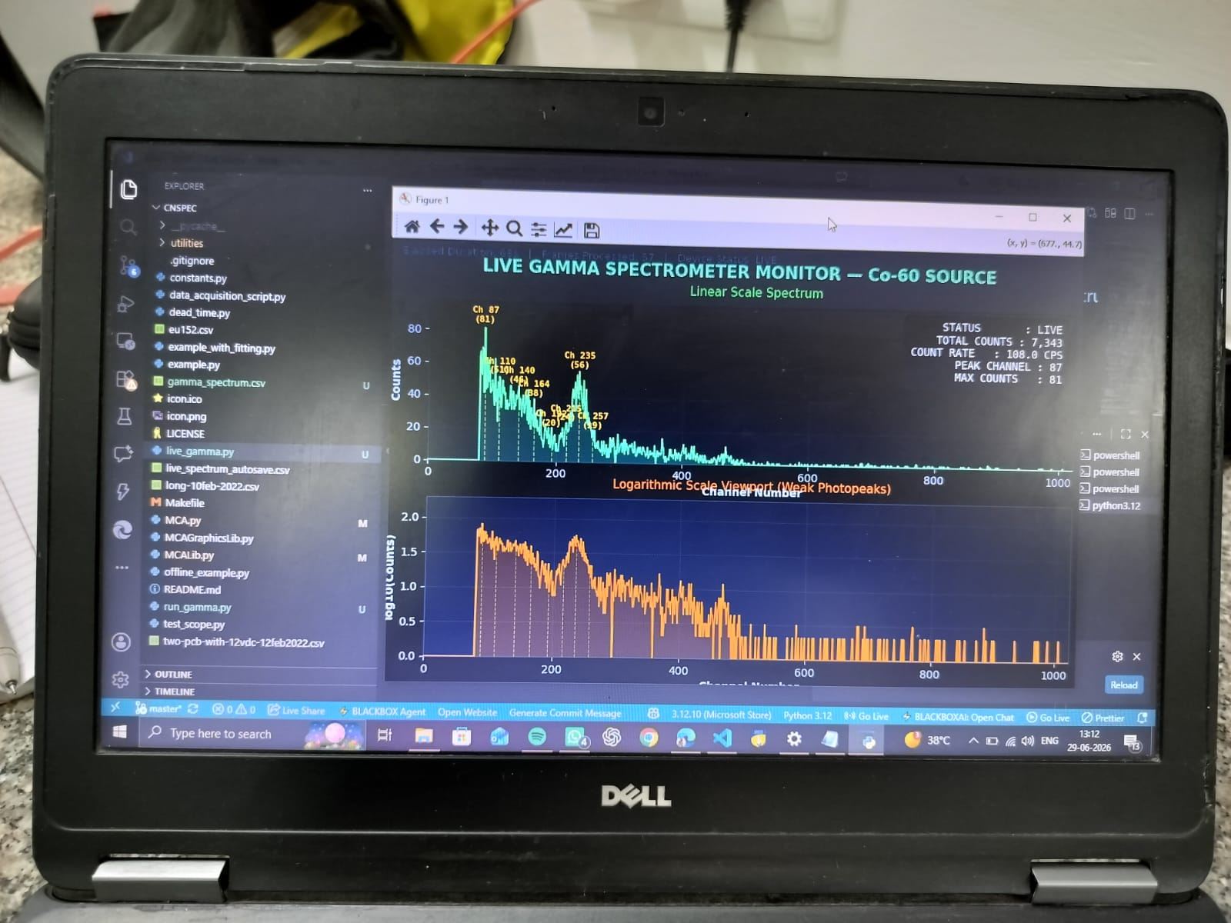
Figure 4: Gamma Spectrometer Setup, Co-60 and Cs-137 Radiation Testing
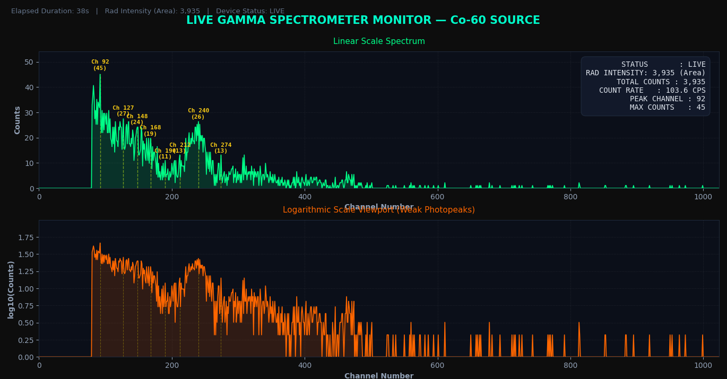
Figure 5: Gamma Spectrum / Peak Detection Graph with Metrics and Radiation Intensity 2D Dynamic Heatmap Generation on real-time basis.
The integration of the Gamma Spectrometer sort of established a solid, continuous radiation tracking base, and it also gave dependable input data for the 2D heat map creation and the 3D Digital Twin display. In a way the validation showed that the system, as it was built, can accurately spot radiation levels, while still keeping steady real time operation, which is kind of the point anyway.

4.5 Development of 3D Digital Twin
The first RADMAP implementation managed to create 2D radiation heatmaps that kind of really showed the radiation intensity across various geographical spots. During later system evaluation though, it was noticed that the usual heatmaps only give a sense of how the radiation levels are spread, but they do not really tell you anything about the likely origin or the actual spatial location of the radioactive source. Because of this, the research and development effort went toward building a “3D Digital Twin” that can offer improved spatial visualization, in a more meaningful way.
A Digital Twin is basically a virtual stand-in for a real physical environment; it keeps taking in real-time sensor feeds and, somehow, ends up mirroring the changes that happen in the area being watched. In this project, we put together a three dimensional visualization framework, by stitching GPS coordinates, gamma radiation readings, environmental sensor signals, and live camera feedback into one unified virtual space.
On the backend side, everything runs continuously, syncing the radiation intensity with the camera frames and the matching geographical location, so the monitored region looks alive and changes as expected. And yeah, unlike traditional heatmaps, this 3D Digital Twin lets users explore the radiation distribution inside a three dimensional spatial context, which makes environmental interpretation much easier and boosts situational awareness, in a more immediate way than before.
To further improve visualization, we designed a night-vision-inspired color grading approach where various radiation intensity bands get shown through several color gradients. The lower radiation areas were rendered with cooler hues, while the higher intensity zones used warmer colors, so that radiation hotspots can be spotted immediately during live monitoring, even when things are fast.
The Digital Twin setup was planned to be modular and scalable so that, later on, we can plug in LiDAR sensing, SLAM (Simultaneous Localization and Mapping), AI-based radioactive source localization, autonomous robotic navigation, and drone-supported radiation mapping. In general, this work should act as the base layer for the next era of intelligent radiation monitoring systems.
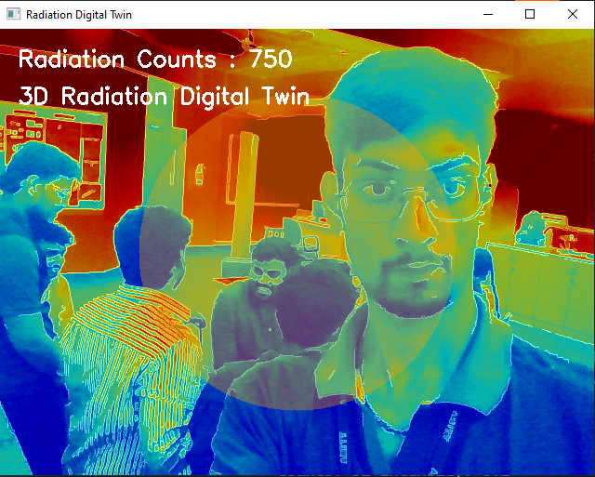
Figure 6: 3D Digital Twin Visualization
A real-time color grading algorithm inspired by night vision imaging technology was designed to represent varying radiation intensity levels. Different colors were assigned according to measured radiation counts, allowing intuitive identification of radiation hotspots directly on the live camera feed. This approach significantly improves visualization and situational awareness during radiation monitoring. SLAM Model Equation given here:
Xt​=f(Xt−1​,Ut​,Zt​)

4.6 Backend System Developments
RADMAP bits together into one platform, for real time radiation monitoring. It set up communication between the Raspberry Pi-5, the Gamma Spectrometer, the GlobalSat BU-353N GPS Receiver, several environmental sensors and the camera module. After that, the system synchronized radiation readings, GPS coordinates, temperature, humidity, and a timestamp, to make 2D heatmaps and also allow 3D Digital Twin visualization. Overall, this bundled architecture keeps the data handling running smoothly and it lays a scalable foundation for future improvements like AI based source localization and autonomous radiation monitoring, which is pretty handy.
Key Outcomes
• I sort of integrated all the hardware components into one unified backend, you know, it’s like all the parts come together there.
• I enabled real time sensor data acquisition, and did the synchronization, so it all runs in step, basically as it happens.
• Support for 2D heatmap and also 3D Digital Twin visualization, kind a like a live model view in the background too.
• Developed a reliable data processing pipeline.

4.7 End-to-End Architecture of the GPS-Enabled Radiation Mapping System
A 3D prototype model of the RADMAP system was put together to kind a mirror the final hardware setup, with the Raspberry Pi-5, Gamma Spectrometer, GlobalSat BU-353N GPS Receiver, a set of environmental sensors and also a camera module. Besides the physical prototype, there was a 3D SLAM (Simultaneous Localization and Mapping) model built, meant to form a digital version of the surrounding area, sort of like a living map. This SLAM model works as the base layer for the 3D Digital Twin, allowing real time mapping and visualization, and in the future it supports radioactive source localization. Taken as a whole, the complete prototype gives a scalable ground platform for field use, autonomous navigation and more advanced radiation monitoring use cases, all connected in one approach.
So the proposed RADMAP architecture kind of sticks to a four-layer setup, made up of the IoT Sensor Layer, the Data Integration Layer, the Digital Twin Modelling Layer, and that Decision Intelligence Layer. In the IoT part it gathers real-time radiation readings, GPS coordinates, also temperature, humidity, and camera outputs using the Gamma Spectrometer, the GlobalSat BU-353N GPS Receiver , plus a Raspberry Pi-5 and some environmental sensors. After that, the Data Integration Layer does the usual kind of work, it pre-processes, synchronizes, and stores what was collected, so later on it can be analysed properly. Then in the Digital Twin Modelling Layer it builds 2D radiation heatmaps along with a 3D Digital Twin by pulling together GPS, SLAM, and live camera feedback, this should help with spatial visualization more and it also supports future radioactive source localization.
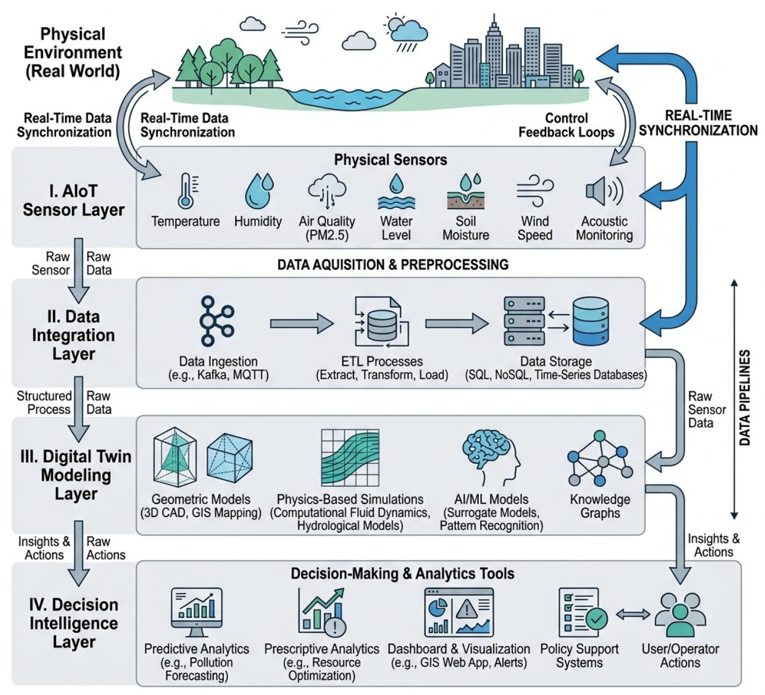
Figure 7: Overall Architecture of the RADMAP System layered-wise manner.
4.8 Prototype Design and SLAM Model
A 3D prototype model of the RADMAP system was made to kind of show the final hardware arrangement, it includes the Raspberry Pi-5, a Gamma Spectrometer, the GlobalSat BU-353N GPS Receiver, assorted environmental sensors and also the camera module. Beside the physical prototype, there was also a 3D SLAM model, Simultaneous Localization and Mapping, worked on to build a digital version of the nearby area. This SLAM piece basically becomes the base for the 3D Digital Twin, allowing real-time mapping, visualization, and later on radioactive source localization. Altogether the full prototype acts like a scalable setup for field deployment, autonomous navigation, and broader radiation monitoring use cases. And then at the end, the Decision Intelligence Layer presents the processed outputs through interactive dashboards, radiation analytics, and live visualization, which in practice supports radiation monitoring, decision making, and yeah, those future AI-based, autonomous mapping style scenarios too.
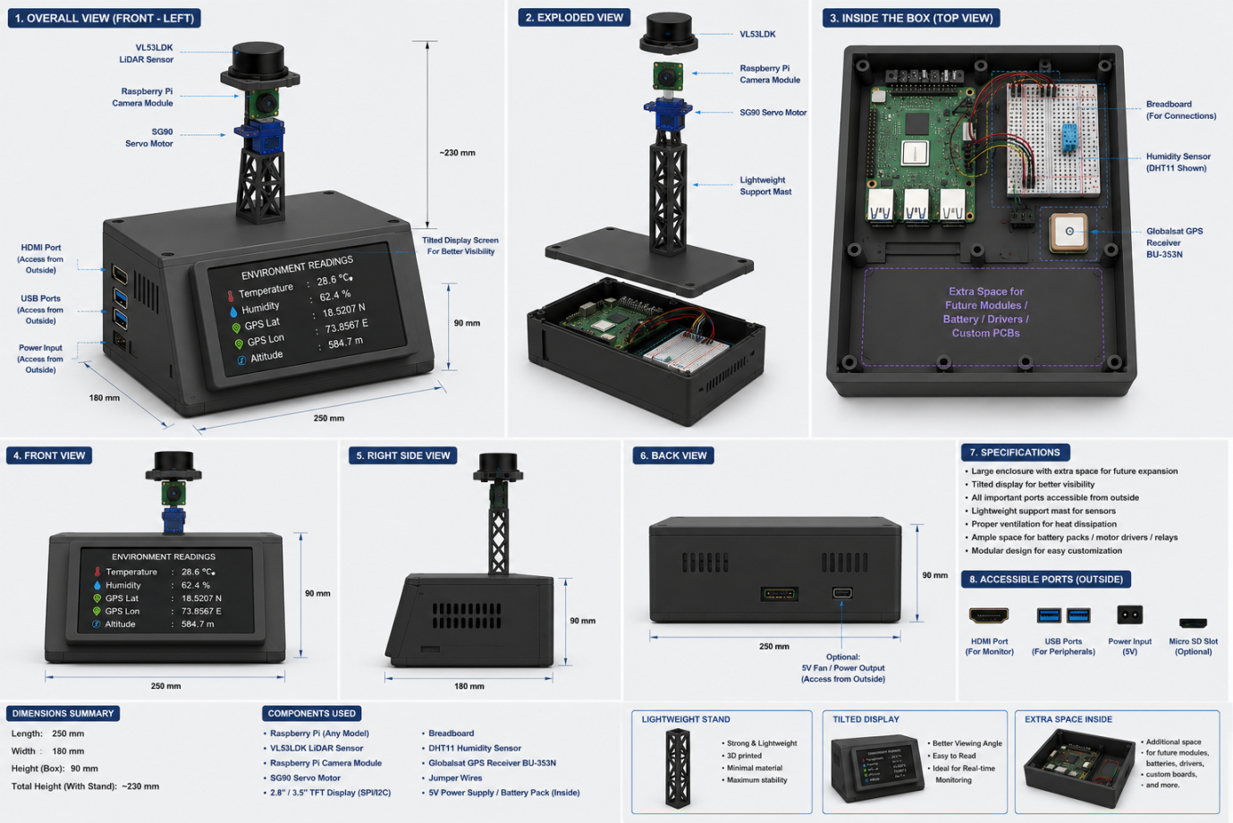
Figure 8: 3D Printed Prototype / CAD Model

